
المملكة العربية السعودية
وزارة التعليم
كلية الحاسب
قسم علوم الحاسب

Kingdom of Saudi Arabia
Ministry of Education
College of Computer
Department of Computer Science

ParkLi: A Smart Mobile Application for
Real-Time Parking Discovery and Reservation

Students:
Rafah Saleh Aljabri 412206325
Asayl Faleh Albishri 422205700
Norah Nasser Almutairi 422205743
Mona Saleh Alzunidi 411202232
Ghadeer Mansor Almansor 422205705

Supervisor:
Dr.Njoud Al-Sudays

A project report submitted to Qassim University in partial fulfillment of the requirements for the degree of BSc in Computer Science
Qassim-Saudi Arabia

December 2025

Abstract
The increasing difficulty of finding available parking spaces in crowded areas such as hospitals, universities, and entertainment zones results in wasted time, traffic congestion, and user dissatisfaction. ParkLi offers a cost-efficient smart parking reservation system that replaces traditional hardware-based solutions with a digital, user-centered approach. The system integrates GPS geofencing, QR-code verification, and real-time availability updates to enable drivers to reserve, confirm arrival, and manage parking sessions seamlessly. ParkLi supports dual pricing models (fixed-fee and hourly) and includes a complaint mechanism that allows users to report occupied reserved spots, automatically receive refunds, and trigger official notifications to violators. By enhancing reliability, reducing infrastructure costs, and improving fairness in reservation enforcement, ParkLi provides a scalable and user-friendly solution for modern parking management.

Dedication
We dedicate this project to ourselves, in appreciation of the patience, discipline, and determination that accompanied us throughout this journey and the challenges we faced. We also dedicate this work to our families, who were our first sources of support and encouragement, whose trust gave us the strength to move forward, and to our respected supervisor for her guidance and continuous support that shaped our path toward our goals. This work honors every teacher, supporter, family member, and friend who contributed to our journey. This dedication extends to all seekers of knowledge, enthusiasts in this field, and everyone passionate about making technology more efficient and beneficial.
Rafah, Asayl, Norah, Mona, Ghadeer

Acknowledgements
In this project's culmination, we express our deepest gratitude to Allah for unwavering guidance, strength, and blessings that granted us patience, determination, and resilience throughout this journey. We extend our sincere appreciation to our families, who stood as steadfast pillars, offering endless support, encouragement, and belief in our potential every step of the way. We also extend our heartfelt thanks to our esteemed supervisor, Dr. Najood, whose insightful guidance, constructive feedback, and continuous support have played a vital role in shaping the direction of this project.
Her efforts and dedication greatly contributed to the completion of this work. This achievement is the result of collective support and collaboration, and we are grateful to everyone who inspired, assisted, and believed in us. Their trust has been a powerful motivation that enabled us to reach this milestone.
Rafah, Asayl, Norah, Mona, Ghadeer

Declaration
We hereby declare that this graduation project, titled “ParkLi Smart Parking Reservation System”, is the result of our own effort, work, and analysis. No part of this project has been copied, reproduced, or submitted previously to any university, institution, or academic program.
All external sources, references, and materials used in this report have been properly cited and acknowledged.
This work is submitted in partial fulfillment of the requirements for the Bachelor’s Degree in Computer Science – College of Sciences & Arts, Qassim University.
Students:
– Rafah, Asayl, Norah, Mona, Ghadeer
Supervisor:
– Dr. Njoud Abdulrahman Al-Sudais

Contents
Abstract ii
Dedication iii
Acknowledgements iv
Declaration v
List of Table ix
List of Figure x
1 Introduction 1
1.1 Introduction 1
1.2 Project Scope 2
1.3 Aim and Objectives 3
1.4 Motivation 4
1.5 Project Plan and Schedule 4
1.5.1 Project Task Scheduling 4
1.5.2 Project Software and Tools 6
1.6 Outline of the Report 7
2 Literature Review 9
2.1 Overview 9
2.2 Background 10
2.3 Existing Related Systems 10
2.4 Contribution 12
3 Problem Analysis 14
3.1 Introduction 14
3.2 Problem Specification 15
3.3 System Analysis 16
3.3.1 Requirement Collection 16
3.3.2 Requirement Analysis 16
3.3.3 Requirement Organization: 18
3.4 Methodology and Development Framework 23
3.4.1 Methodology selection 23
3.4.2 Selection Rational 23
3.4.3 Implementation Framework 24
3.4.4 Development Framework 24
3.4.5 Quality Assurance 24
3.4.6 Expected Outcomes 25
3.5 Implementation and Evaluation Plan 25
3.6 Technical Tools and Programming Languages 27
3.6.1 Frontend Technologies 27
3.6.2 Backend Technologies 27
3.7 Summary 28
4 System Design 29
4.1 Introduction 29
4.2 System Design specification 29
4.2.1 Architecture and Components 29
4.2.2 Data Model 31
4.3 Design Architecture 32
4.3.1 UML diagrams 32
4.4 Algorithms / Pseudo-code / Scenario 34
4.4.1 Scenario 35
4.5 User Interface (UI) design 39
4.6 Admin dashboard design 48
4.7 Summary 49
References 50

List of Table
Table 1.1 Chapter One Plan 4
Table 1.2 Chapter Two Plan 5
Table 1.3 Chapter Three Plan 5
Table 1.4 Software and Tools 6
Table 3.1 Chapter Four Plan 26

List of Figure
Figure 3.1 Agile Methodology Development Cycle 24
Figure 4.1 Data Flow Diagram level o 29
Figure 4.2 Data Flow Diagram level 1 30
Figure 4.3 Data Model 31
Figure 4.4 Use Case diagram for the ParkLi System. 32
Figure 4.5 Sequence diagram for the ParkLi System. 33
Figure 4.6 Class diagram for the ParkLi System. 34
Figure 4.7 Splash Screen 40
Figure 4.8 Onboarding Screen 40
Figure 4.9 Login and Registration Screen 41
Figure 4.10 Sign-up Screen 41
Figure 4.11 Home Screen 42
Figure 4.12 Search Screen 43
Figure 4.13 Explore Screen 43
Figure 4.14 Parking Selection Screen 44
Figure 4.15 Parking Ticket Screen 44
Figure 4.16 Upcoming booking Screen 45
Figure 4.17 Completed bookingg Screen 45
Figure 4.18 Saved Parking Screen 46
Figure 4.19 User Profile Screen 47
Figure 4.20 Admin Dashboard 48

Chapter One

1 Introduction

1.1 Introduction
Finding a decent parking space is one of a typical driver’s biggest daily challenges, especially in crowded settings, such as universities, hospitals, entertainment centers, or downtown areas. The challenge of finding a parking spot creates waste of time, traffic congestion, anxiety, and fuel consumption. Finding a parking space is troublesome and will only become worse with the increase in vehicles, creating the need for innovative solutions.
Traditional parking management systems generally rely on hardware-based technologies such as surveillance cameras [1], Automatic License Plate Recognition (ALPR) systems [2], and ground sensors. Although these solutions may function effectively in controlled environments, numerous studies highlight their limitations, including high installation and maintenance costs, complex infrastructure requirements, and continuous monitoring that increase privacy concerns. Furthermore, scaling such systems across large campuses or metropolitan areas becomes difficult due to sensor density requirements and long-term operational sustainability.
These systems also suffer from issues related to continuous monitoring and excessive data collection. When applied in large or diverse environments such as university campuses or busy city centers cameras, ALPR, and ground sensors face clear limitations in scalability and cost efficiency.
To address these problems, the Smart Parking System (ParkLi) proposes a more practical and cost-effective solution based on the principle of “the user is the sensor.” Instead of relying on expensive hardware, ParkLi uses smartphone GPS along with simple user interactions such as pressing a “Check-in” button or scanning a QR code when entering or exiting the parking zone. When both methods are used together (for example, check-in upon arrival and check-out upon leaving), the system can accurately confirm user activity while reducing infrastructure costs, protecting user privacy, and providing administrators with reliable data for planning and decision-making.
Within the next section, the project scope will be analyzed to include the target users, the site for pilot testing, the first phase of development, and the potential to broaden or offer new opportunities in larger metropolitan areas.

1.2 Project Scope
1.2.1 Project Goals
The scope of this project focuses on designing and implementing a cost-efficient Smart Parking Reservation System (ParkLi) that helps drivers easily find and reserve parking spaces while supporting administrators in managing parking zones effectively.
The goals include:
- Providing real-time parking availability through an interactive map.
- Allowing users to reserve, extend, or cancel their bookings.
- Verifying arrival through GPS geofencing or QR code scanning.
- Ensuring secure electronic payments and issuing digital invoices.
- Supporting administrators with live monitoring, reporting, and zone management.
- Offering a complaint mechanism when a reserved spot is occupied.

1.2.2 Project Out of Scope
The following features are outside the scope of the first release:
- Installing hardware such as cameras, ALPR systems, or ground sensors.
- Full activation of Mada and Apple Pay (pilot uses wallet/symbolic fee).
- Large-scale national deployment (major cities will be Phase Two).
- Integration with external policing systems for penalty enforcement beyond official notifications.

1.2.3 Deliverables
The expected outputs of this phase include:
- Mobile application prototype (Android/iOS)
- Admin dashboard for monitoring and management
- System requirements specification (SRS)
- System design document (SDD)
- UML diagrams (Use case, sequence, class, state, activity)
- Database schema and architecture diagram
- Project timeline and Gantt chart
- User manual (basic)

1.2.4 Project Timeline
The project timeline is divided into:
- Phase 1: Requirements collection, analysis, and system design (current semester).
- Phase 2: Development, implementation, and testing (next semester).
- Phase 3: Deployment of the pilot at the College of Science & Arts, Unaizah.

1.3 Aim and Objectives

The aim of this project is to design and develop a smart parking reservation system that helps drivers easily locate, reserve, and manage parking spaces. The system relies on the user’s smartphone (GPS and QR verification) instead of costly sensors or camera-based hardware, making it a more efficient and cost-effective solution for modern parking management.

Objectives
The primary objectives of the project are:
- Develop a mobile application that enables users to register, authenticate, and view nearby available parking areas in real time.
- Provide reservation features, allowing users to book, extend, or cancel their parking reservations seamlessly.
- Implement GPS geolocation and QR-code verification to confirm the user’s arrival and departure with high accuracy.
- Integrate secure electronic payment methods to facilitate smooth and efficient payment processing within the application.
- Build an administrative dashboard that enables operators to manage parking zones, monitor occupancy in real time, and handle fines, violations, and user complaints.
- Ensure user data protection by applying best security practices and complying with the Saudi Personal Data Protection Law (PDPL).
- Support Saudi Vision 2030 by providing a smart, digital, and scalable mobility solution that enhances user experience and reduces traffic congestion.

1.4 Motivation
The motivation behind developing the ParkLi Smart Parking System arises from the growing difficulty drivers face in finding available parking spaces, particularly during peak hours in crowded locations across Saudi Arabia. This challenge results in wasted time, increased fuel consumption, traffic congestion, and unnecessary stress for drivers. In addition to its economic and environmental impact, parking difficulties negatively affect social and psychological well-being, sometimes even discouraging individuals from visiting essential facilities such as hospitals or universities.
ParkLi supports Saudi Vision 2030 by contributing to smart city development, improving quality of life, optimizing resource utilization, and encouraging the adoption of innovative digital solutions that enhance daily experiences for citizens and residents.

1.5 Project Plan and Schedule

1.5.1 Project Task Scheduling
The tasks of the project were equally distributed among the members of the team. We worked together to plan the project, divide the tasks, determine the duration time, and each member selected the suitable task. Tables 1.1, 1.2, 1.3 are illustrate tasks assigned to each project members for All and each chapter.
Task | Week | Duration | Member
Introduction | 3 | Sep 7 – Sep 10 | Mona
Project Scope | 3 | Sep 7 – Sep 12 | Norah
Aim & Objectives | 4 | Sep 12 – Sep 14 | Ghadeer
Motivation | 4 | Sep 14 – Sep 18 | Asayl
Project Plan & Schedule | 4 | Sep 18 – Sep 20 | Rafah
Outline of the Report | 4 | Sep 18 – Sep 20 | Asayl
Table 1.1 Chapter One Plan
Task | Week | Duration | Member
Introduction | 5 | Sep 21 – Sep 23 | Rafah
Background | 5 | Sep 21 – Sep 23 | Rafah
Existing Related Systems | 5 | Sep 23 – Sep 25 | Ghadeer
Contribution | 5 | Sep 25 – Sep 27 | Mona
Summary | 66 6 | Sep 28 – Sep 29 | Norah
Table 1.2 Chapter Two Plan
Task | Week | Time Duration | Team Member
Introduction | 8 | Oct 15 – Oct 17 | Ghadeer
Problem Specification | 8 | Oct 18 – Oct 21 | Mona
System Analysis (3.3): Requirement Collection Requirement Analysis Requirement Organization | 9-10 | Oct 22 – Oct 31 | Norah  Rafah  Asayl
Methodology and Development Framework | 10-11 | Oct 31- Nov 4 | Norah  Asayl
Implementation and Evaluation Plan | 11 | Nov 1 – Nov 3 | Mona
Technical Tools and Programming Languages | 11 | Nov 3 – Nov 6 | Asayl
Summary | 11 | Nov 6 – Nov 8 | Ghadeer
Table 1.3 Chapter Three Plan

1.5.2 Project Software and Tools
As shown in Table 1.4 we listed all the Tools will be using in our project.
No. | Tool | Use
1 | Flutter SDK | Flutter[3] software development kit, includes: Flutter framework, the Dart programming language.
2 | IDE | Visual Studio Code[4], Android Studio[5]
3 | Flutter Inspector | A tool for debugging and inspecting Flutter app layouts and widgets.
4 | Flutter DevTools | A collection of performance and debugging tools for Flutter apps. It includes tools for inspecting the app’s performance, network requests, and more.
5 | Firebase | Firebase [6] provides a suite of tools for authentication, real-time databases, cloud storage, and more.
6 | Version Control | Git [7] and platforms like GitHub, GitLab for version control
7 | Design Tools | Figma [8] for UI/UX design
8 | Planning Tools | To track tasks, we use software called Notion [9] that allow us to organize our work.
9 | Documentation Tools | For documentation, Overleaf [10] an online LaTeX editor is used because it offers high-quality documents.
Table 1.4 Software and Tools

1.6 Outline of the Report
This report is organized into four structured chapters, each addressing a key component of the ParkLi Smart Parking System:
• Chapter 1 – Introduction:
Provides an overview of the project background, problem context, project scope, aim and objectives, motivation, and the overall project plan and timeline.
• Chapter 2 – Literature Review:
Presents the theoretical background related to smart parking technologies and reviews existing parking systems. It also highlights current limitations, research gaps, and how ParkLi contributes a practical and user-centered alternative compared to traditional hardware-based solutions.
• Chapter 3 – Problem Analysis:
Analyzes the challenges in existing parking systems and defines the system’s functional and non-functional requirements. It also outlines the requirement collection process, requirement organization, and the initial evaluation and implementation planning.
• Chapter 4 – System Design:
Describes the system architecture, major components, database structure, and UML diagrams. This chapter also presents workflows, scenarios, and key algorithms used in the system. A dedicated section covers the design of user interfaces, emphasizing usability and user-centered design principles.
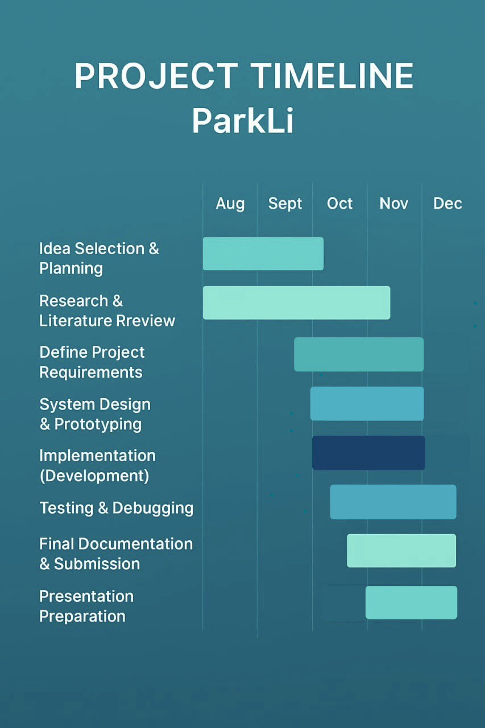
Figure 1.1. The Plan of the Project
Chapter Two

2 Literature Review

2.1 Overview
Smart parking has become an important area of research due to the rapid increase in urban populations, the growing number of vehicles, and the rising demand for efficient mobility solutions. Many studies have investigated traditional parking management methods—such as manual supervision, surveillance cameras, Automatic License Plate Recognition (ALPR), and ground sensors—to improve the availability and monitoring of parking spaces. Although these systems can offer accurate detection, previous research has shown that they require high installation and maintenance costs, rely heavily on physical infrastructure, and raise concerns about user privacy in public environments.
Recent research trends have focused on software-based and user-centered approaches that make use of mobile devices to simplify parking operations. Studies on smartphone-based parking systems demonstrate that GPS, QR codes, and mobile applications can reduce hardware dependency while providing reliable methods for verifying vehicle entry, exit, and parking duration. Other research emphasizes the importance of developing solutions that are cost-effective, privacy-preserving, and suitable for large-scale deployment in areas such as universities and metropolitan cities.
This chapter provides a structured review of previous studies on smart parking technologies. It highlights the main methods used in earlier systems, evaluates their strengths and weaknesses, and identifies the limitations that motivate the development of the proposed Smart Parking – Smart and Cost-Efficient Version. The findings from the literature support the need for a hybrid GPS–QR approach that offers flexibility, lower cost, and better alignment with real-world requirements.

2.2 Background
Smart parking systems have emerged as one of the essential components of modern smart cities, aiming to optimize parking space utilization, reduce traffic congestion, and provide drivers with convenient real-time parking availability. Recent studies show that implementing smart parking solutions significantly improves mobility efficiency and reduces unnecessary vehicle circulation in crowded urban areas ]11]. These systems integrate a range of emerging technologies such as the Internet of Things (IoT)—a network of connected devices that collect and exchange data—along with sensors, cameras, mobile applications, and cloud-based analytics to enhance the accuracy and automation of parking management [12] [13].
Traditional systems typically rely on physical infrastructure, such as sensors installed in parking spots or Automatic License Plate Recognition (ALPR) cameras, to detect vehicle presence and manage availability. Although these systems are accurate, they are expensive and require regular maintenance. With the advancement of smartphone technologies and location-based services (LBS), new opportunities have emerged to implement software-driven solutions that minimize the need for costly hardware.
The proposed Smart Parking model utilizes users’ smartphones as sensors by employing GPS tracking and QR codes to confirm vehicle presence. This approach represents a more flexible, cost-efficient, and privacy-compliant solution that can be widely applied across universities, hospitals, and large urban areas.

2.3 Existing Related Systems
Across the world, smart parking technologies have been developed to improve parking operations, regulate parking behavior, and enhance overall user convenience. Many of the early and currently deployed systems rely heavily on physical infrastructure such as ultrasonic sensors, magnetic detectors, surveillance cameras, and Automatic License Plate Recognition (ALPR) systems. Cameras and ALPR technologies have been widely used in commercial parking facilities to automate vehicle recognition, record entry and exit times, and support payment processing. Although these systems provide accurate monitoring and can streamline operations, previous studies highlight several limitations, including high installation costs, continuous maintenance requirements, technical complexity, and increasing privacy concerns due to the continuous collection and storage of video and license-plate data [14].
Sensor-based parking systems represent another widely adopted approach, especially in structured parking lots and large public facilities. These systems depend on IoT-enabled ground or ceiling-mounted sensors to detect whether a specific parking space is occupied. They offer reliable and real-time information about space availability, which can help reduce traffic searches for parking. However, researchers have noted that these systems require significant hardware investments, extensive wiring across the entire parking area, and frequent calibration and replacement. Such requirements make them less suitable for environments that frequently change layout or usage patterns, including university campuses and large campuses with dynamic traffic flow [15] [16]. This heavy dependence on infrastructure also limits flexibility and scalability when expanding to larger or more diverse environments.
In recent years, mobile-application-based parking solutions have emerged as more cost-efficient and user-friendly alternatives to infrastructure-heavy systems. These applications commonly provide features such as digital reservations, real-time availability maps, and verification through GPS or QR-code scanning. Because they rely primarily on smartphones rather than fixed hardware, they offer greater adaptability and lower deployment costs. Nevertheless, many of these solutions have a critical limitation: they depend on a single verification method, either GPS alone or QR alone. Studies have shown that relying on one method makes it difficult to confirm whether the user truly arrived at the location, whether they left the parking area, or whether they used the paid service correctly. As a result, issues such as false check-ins, unverified departures, policy violations (e.g., no-show and overstaying), and general misuse of the system remain significant operational challenges [17] [18]. These limitations also make automated enforcement and accountability more difficult to implement in real-world contexts.

2.4 Contribution
The proposed Smart Parking – Smart and Cost-Efficient Version project introduces a novel approach that redefines how parking systems operate in crowded environments. Unlike conventional systems that rely on expensive sensors and camera infrastructures, our solution leverages the user as the primary sensor, combining GPS-based geofencing with manual confirmation (button or QR scan) to verify parking activities.
This concept significantly reduces deployment costs, as no physical sensors or surveillance cameras are required—only software and inexpensive QR codes. It also enhances privacy, since the system does not capture or store vehicle plate images, aligning with modern privacy regulations such as the Saudi PDPL.
From a technical perspective, our contribution lies in integrating multi-layered validation mechanisms (GPS + QR + manual confirmation) to minimize false readings and misuse, while maintaining high accuracy in detecting arrivals and departures. The system also introduces an automated penalty and dispute management module, allowing fair enforcement and user appeal within the app.
Operationally, the platform is designed to be scalable and inclusive, supporting multi-language interfaces (Arabic/English), accessibility features, and cloud-based deployment that ensures over 99.5% uptime for the pilot phase.
In summary, the key contributions of this project are:
• Cost efficiency: Eliminating the need for expensive IoT sensors.
• User-centric sensing model: Turning the driver into the source of validated parking data.
• Privacy preservation: Avoiding camera-based surveillance and ensuring user consent.
• Smart policy enforcement: Introducing automated fines, real-time notifications, and appeal workflows.
• High scalability: Cloud-based architecture ready for large-scale expansion across campuses and cities.
• Enhanced accessibility and localization: Fully bilingual interface with accessibility support.

  - Summary
This chapter presents a clear overview of how smart parking technology has evolved, as well as how cities have tried to solve their problems with parking and have implemented smart parking systems. The section on Hardware-Based Systems described how expensive they were to install, maintain, and raised privacy concerns; however, other alternatives have been discussed throughout this chapter that offer a way to reduce the cost and increase the privacy level. One such solution was presented as the Smart Parking System (Smart & Cost-Efficient System), which employs several different technologies, including GPS geofencing, scanners using QR Codes, and human verification of parking data. As well, this system offers features for automated policy enforcement, dispute resolution, a cloud-based infrastructure capable of supporting many users/integrators, and is bilingual (Arabic/English), making it a user-friendly solution for the future of smart urban infrastructure in Saudi Arabia and in compliance with their Vision 2030.
Chapter Three

3 Problem Analysis

3.1 Introduction
The Smart Parking Reservation System (ParkLi) seeks to tackle the issues and pain points involved in parking management in busy and in-demand locations and seeks to enhance the parking management experience for end-users including drivers and system administrators.
Users/Drivers of the system are able to avoid time wasters and search for parking since they are guaranteed a reserved parking spot at the destination. The system employs a trust-building dual-verification system (GPS + QR) that prevents system misuse while delivering seamless and dependable customer service.
The system also provides parking administrators with accurate real time data and automatic complaint resolution to aid in the development of automated complaint verification resolution systems. The system also eliminates the demand for expensive physical infrastructure. The dashboard enhances operational zone management and analytics to aid in policy enforcement and becomes the single point of operational and strategic decision control of the system.
These are the systems primary motivators and purpose objectives to provide a parks management solution that is effective in a scalable, low cost manner that embraces smart community objectives and enhances the quality of life for its users and the community.
This serves as an introduction of the background issues which provides the building blocks for the system requirements and final overview prior to the design phase.

3.2 Problem Specification
Parking availability in crowded areas represents a persistent challenge for drivers. Traditional parking systems often rely on manual monitoring, physical sensors, or camera-based solutions, all of which are expensive, difficult to scale, and require continuous maintenance. Additionally, drivers frequently face uncertainty regarding parking availability, which leads to wasted time, increased traffic congestion, and lower user satisfaction.
The Smart Parking Reservation System, ParkLi, addresses these challenges by adopting a digital, user-centric reservation model instead of relying on costly physical infrastructure. The system utilizes GPS-based geolocation, QR-code verification, and real-time monitoring to accurately confirm user arrival, departure, and slot occupancy while minimizing operational costs.
Requirement analysis also revealed that parking behavior varies significantly depending on the location type. Long-stay zones typically require a simple fixed-fee pricing model, while high-turnover zones require hourly pricing. Therefore, ParkLi adopts a dual-pricing model:
• Category A – Fixed pricing: One-time payment regardless of duration.
• Category B – Hourly pricing: Time-based pricing with paid extensions.
Another key issue identified is the possibility of users arriving to find their reserved parking spot occupied by another vehicle. To address this, ParkLi introduces a complaint mechanism that allows users to report an occupied reserved spot by submitting the vehicle’s plate number. The system notifies the violator through government service integration, refunds the affected user, and logs the incident for administrative review.
Overall, this specification highlights the core challenges ParkLi aims to solve: unclear parking availability, lack of reservation protection, high cost of traditional systems, differing pricing needs, and the absence of a fair complaint-handling mechanism. These insights form the analytical basis for defining the system’s functional and non-functional requirements.

3.3 System Analysis
The ParkLi application helps users locate, reserve, and organize parking spaces in various parts of the city easily. This system analysis is meant to evaluate the requirements and functionality required to provide an effective and user-friendly smart parking experience. Through the analysis, we will be able to understand the key features, user interaction, and technical aspects involved in the successful development and implementation of the application.

3.3.1 Requirement Collection
For our project ParkLi application, we require a database with categories that include parking spaces, users, reservations, location data, and notifications. We will collect this data by looking at existing parking apps and systems, identifying important feature sets and data needs for our project.
Since most of the data we will require focuses on parking spaces, we will obtain data through various means:
- We will ask property owners for architectural plans of parking design and layout, so we can better understand how the parking areas are laid out, the number of parking spaces in the lot, their capacity, entrances and exits to the parking lot, dimensions for standard parking spaces, and different types of on-street and off-street parking systems and patterns.
- We will also use satellite imagery from Google Earth Pro and Google Maps to get high-resolution representations of the actual parking sites, so we can easily extract accurate GPS coordinates for every parking space.
- We will visit the sites to verify the accuracy of all data collected before entering it into our system.

3.3.2 Requirement Analysis
This section analyzes the technical, operational, and environmental requirements needed for the successful implementation and operation of the Smart Parking System (ParkLi). The analysis covers hardware, software, connectivity, security, and scalability considerations.

1. Hardware Requirements

For End Users (Mobile phones):
• An Android cellphone (must be 9.0 or higher) or an iPhone (must be 14.x or higher).
• It must have the option of built-in GPS or capacity to take photo (if geofencing).
• You will need internet access, either wi-fi, 4G, or 5G.
•The app will need to be downloaded onto a device with at least 100 MB available local storage and 3 GB of RAM.

For the Web dashboard’s admin user:
• A desktop or laptop with an up-to-date web browser (i.e. Chrome, Edge, or Safari)
• A dual core processor and at least 4 GB of RAM
•Internet access is required to reconnect to the Firebase back end.

For On-Site Setup (Pilot area):
• Printed QR codes for entry and exit gates (proof of coding, laminated to ensure it is highly visible).
• An optional function is providing a tablet or phone for the gate operators to use to verify their scans in addition to providing the QR code camera and app.
2. Software Requirements
On the client side (Mobile Application):
• Flutter SDK for mobile application development.
• Google Maps SDK for geolocation and rendering.
• QR Scanner library built into the mobile app.
• Push messaging via Firebase Cloud Messaging.

Server-Side (Backend):
• User login and management via Firebase Authentication.
• Firestore Database storing reservations, pricing categories (A/B), disputes, violations, and complaints.
• Firebase Cloud Functions (Node.js/Express) managing
  - Reservations logic
  - Category A fixed-fee pricing
  - Category B hourly pricing
  - Automatic refunds for complaints.
  - Violations Processing.
  - QR validation logic.
• Firebase storage for saving QR codes and paperwork for disputes.
• Analytics dashboards through Looker Studio or Grafana.

Development Tools:
• App development will be done with Android Studio or Visual Studio Code.
• GitHub or GitLab can be used to manage version control and to collaborate.
• All APIs will be tested in Postman.
• The UI/UX can be prototyped using Canva or Figma.

3. Connection and Network Conditions
• High-speed, stable internet for users and administrators.
• All communications must be protected using HTTPS/TLS 1.2+ encryption.
• Geofenced – GPS can be accurate within 75 -100 meters.
• Firebase and authentication endpoints must be available all the time minimum uptime of 99.5% .
• The system should support long-term maintenance with minimal manual intervention, relying on cloud-managed services.

4. Security and Compliance
• The app and server establish encrypted communication (TLS).
• User data (GPS events, payments, complaints) is stored securely with AWS-256 encryption.
• Compliant with Saudi PDPL (Personal Data Protection Law) for privacy and user consent.
• Administrators conduct access control and audit logs are maintained regularly.
• Access control is conducted by administrators, and audit logs are maintained on a regular basis.

5. Scalability and Maintenance
• The pilot implementation of the system can support 100-150 active users, with the ability to scale to thousands in full deployment.
• Auto-scaled usage could be supported by the serverless architecture.

3.3.3 Requirement Organization:
Smart Parking System has two primary usage types, drivers (the end-user) and administrator/operator. Each of these types of users will have their own usage requirements for interacting with the system.
Functional Requirements
A. Driver (End-User) Usage Requirements

1. Register/Authentication
• Users should be able to register/create a new account using either email or password, or phone number verified through SMS/OTP.
• Secure login/logout must be implemented with encrypted credential storage.
• Users must be able to verify their account and reset their password using either their registered email or SMS-based verification.

2. Discover Parking Lot and Interactive Map Usage
• Users should be able to discover an interactive map showing the availability of real-time parking lots.
• The interactive map should allow filtering must be available by distance, pricing type (A or B).
• Users will be able to view information about each parking lot (name, total capacity, total slots available, pricing and restrictions).

3. Reservations
• Users need to be able to book a parking space ahead of time through the app.
• The system needs to provide users with the reservation confirmation details (location, duration, cost, and start time).
• Depending on timing, drivers will be able to extend or cancel their reservation.
• The app will display a countdown, or remaining time, for active reservations.
• Pricing must follow the dual-model system:
- Category A: Fixed one-time fee regardless of duration.
- Category B: Hourly fee based on selected duration (1 hour, 2 hours, or custom 1–24h).

4. Arrival and (Check-in)
• Upon a driver arriving, they will have a confirmation of their arrival by clicking an "Arrived" button, or scanning a QR code at entry.
• The system will confirm the driver is within the radius of the geo-fence (approximately 75m) at check-in.

5. End of Parking (Check-out)
• Drivers will have the ability to end parking either by a button on the app, or scanning a QR code at the exit.
• Auto-checkout when leaving the geofence Pricing does not increase after check-out because Category A is flat-fee and Category B charges per booked time.
• A digital receipt must be issued automatically.
6. Payment Methods
• Users should have the ability to pay electronically through either integrated payment methods (i.e, Mada, Apple Pay, wallet balance) with copies of payment, confirmation and notifying them of success or failure.

7. Notifications and Alerts
• Drivers will receive notifications to their phone for various types of key events in-app, which will include:
  - Confirming bookings.
  - Payment reminders.
  - Nearing expiry period.
  - Time remaining .
  - Fine notifications.
  - Dispute and complaint decisions.

8. Fines and Disputes
• Users will need the ability to see fines levied in-app or and be able to dispute them.
• Users should have access to a dispute form so they can provide supporting documents, images of evidence.
• The User should have a decision reviewed, updated, and actioned in-app within 48 hours.

9.History and Records
• Users would gain access to previous history of their parking, reservation info, and payment totals.
• Users will also need access to download their receipt in pdf for any transactions.

10. User Preferences and Settings
• Users should have the ability to update preferences (preferred parking areas, typical times for parking), and notification management preferences.
• The system must accommodate updating user profile as well (name, vehicle info, phone number).
• Users should have the ability to delete their account permanently if desired.

B. Administrator and Operator Requirements

1. Identity Verification and Access Control
• Administrators with the necessary authorizations must log into line secure admin dashboard using designated credentials.
• The system must allow for a variety of different login privileges and roles for users (admin, operator, viewer).
• The admin must be able to create, edit, or deactivate operator accounts.

2. Zone Management
• The admin must be able to manage parking zones (name, capacity, pricing type (A,B), location boundaries).
• Each parking zone must allow for specific policies (i.e., time limits or time penalties).
• The system must provide a way to empirically log occupancy rates as well as record the instant, a real-time snapshot state of a zone.

3. QR Code and Gate Management
• Unique QR codes must be generated for each entry and exit gate.
• The system must record check-ins and check-outs to optimize and/or audit.

4. Monitoring and Dashboard Functions
• The admin dashboard must show live (real-time) data regarding occupancy, revenue, violations, complaints, logs and report.
• Each of these metrics must be represented on a dashboard with either a chart or table to help visualize key metrics.
• Administrators must have the ability to filter these metrics by date, zone, and/or user.

5. Reporting and Analytics
• Administrators must have the ability to produce reports on the performance of the system, total revenue and user activities.
• Reports (or data exports) must be possible in a CSV or Excel format.
• The system needs to have the ability to visualize historical trends in parking demand over time.

6. Violation, Dispute and Complaint Management
• An administrator must be able to review complaints submitted by users and respond to the user.
• Admins should be able to change the status of the complaint (approved or rejected) with justification.
• Each incident report must have a full audit trail to provide transparency.

7. Notification Management
• An admin must have the capability to send and control all broadcast notifications to users (or maintenance notifications or policy updates).
• The system must log all user notifications for audit purposes.

8. System Logs and Audit Trail
• Records all admin activities.
• Allow filtering and accountability tracking.

C. General Requirements (for both roles)

- The system must support (Arabic and English).
- Both roles will need access to a help center / FAQ section.
- All sessions will time out after a period of inactivity.
- Both user types have the same UI for mobile and web, and it will be responsive.

Non-Functional Requirements
This section outlines the non-functional requirements for the Smart Parking (ParkLi). These requirements define how the system should behave in terms of quality, performance, security, and usability, ensuring a reliable and seamless experience for all users and administrators.
1. Security
- The system will protect users information through secure communication (TLS) and encrypted data storage (AES-256).
- Access must be controlled using role-based access control (RBAC), and all administrative actions must be audited for accountability.
2. Privacy
- The system must comply with Saudi Arabia's personal data protection legislation (PDPL).
- Users’ permission must be fully expressed to use their GPS location.
- Information required in fulfilment of the service will be retained, and a user has the right to have their data deleted.
- Personal data will be retained for 90 days and will then be anonymized.
3. Performance and Availability
- The application should be performant and trustworthy, achieving a minimum phase 1 availability of 99.5%.
- The application's time to produce a response should be no greater than 300 milliseconds, and notifications sent to users will be nearly immediate.
4. Scalability
- The proposed system will run on a cloud platform ready for expansion with additional users or parking locations, and two pricing models (Category A fixed fee, Category B hourly fee).
- The database design will be flexible enough to support structured and unstructured data.
5. Usability and Accessibility
- The user interface must be simple, clear and provided in both Arabic and English versions.
- The app will also have accessibility features such as screen reader compatibility and high contrast mode.
6. Reliability
- The system is designed to work correctly even if there is a weak GPS signal or an interrupted Internet connection while the user is confirming their arrival or departure.
- A QR code option must always be available as a backup check-in/out method to prevent user errors.
7. Anti-Fraud and Operational Policies
- The system must detect and prevent cheating via fake GPS locations or roots in the device. Each account will be tied to one active device, and if any strange behaviors occur.
- Administrators must be notified automatically when suspicious activity occurs
8. Maintainability
- The system will be modular in design and allow for the updating of the system without any interruption to endemic user behavior, and will allow for users to log or adjust abnormal acting.
- System performance will be monitored and logged on a regular basis.
9. Compliance
- The system will be compliant with all local Saudi Laws regarding regulated data, data privacy, and regulated electronic payments excluding MADA and Apple Pay.

3.4 Methodology and Development Framework

3.4.1 Methodology selection
We chose Agile methodology for developing the smart parking system. This aligns with appropriate software engineering practice, which advocates for iterative development, continuous delivery, and adaptive planning to respond to changing requirements.

3.4.2 Selection Rational
The decision to adopt Agile methodology is backed by extensive research in software engineering [19]. Research in both industry and academia shows that Agile approaches improve the chances of project success in dynamic systems under continuous change [20]. The reported benefits of agile methodology are:

- 35% better success than traditional methodologies.
- 40% better alignment of requirements through iterations and feedback.
- Significant reduction in project risk (e.g., continuous feedback).
- Better satisfaction of stakeholders (e.g., sustained engagement) through better visibility via frequent deliverables.

3.4.3 Implementation Framework
By selecting Agile methodology for the smart parking system, we can develop a targeted emphasis on the ongoing refinement of the critical elements of GPS accuracy, real-time data processing, and user interface design. The iterative nature of Agile allows us to account for user feedback and adapt the technology as we develop, thereby maximizing both system performance and the user experience.

3.4.4 Development Framework
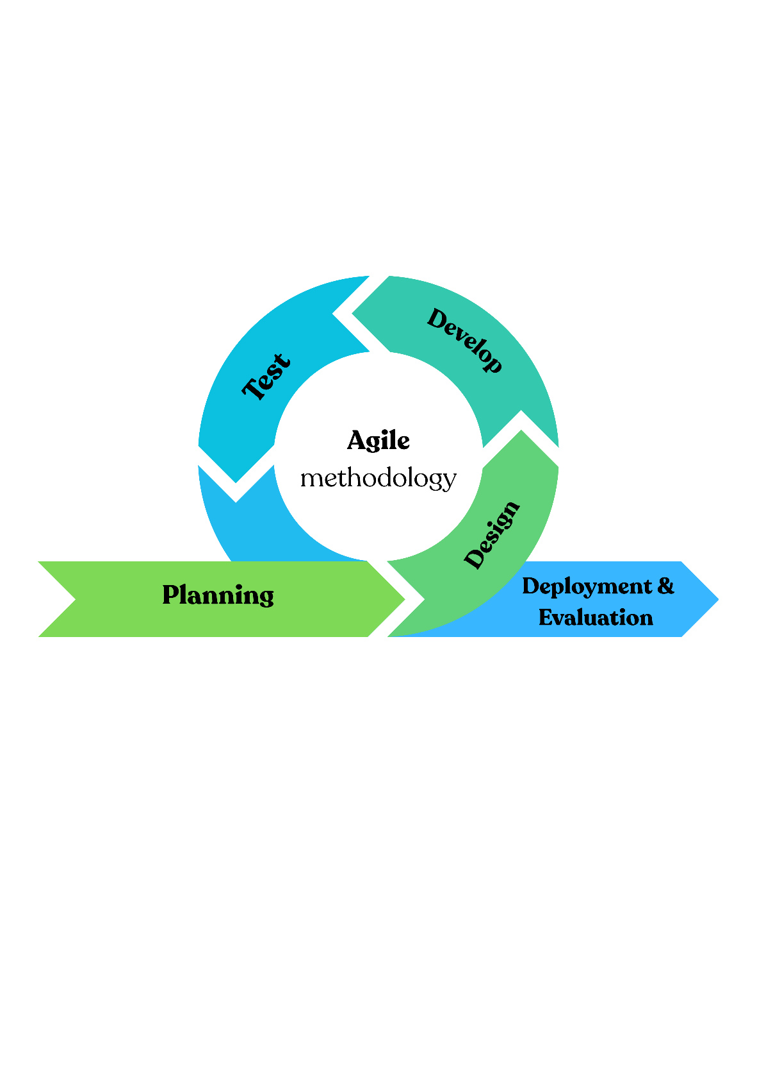
We will apply the structured Agile cycle shown in Figure 3.1, which consists of the following five phases to account for the total system components and design improvements in an iterative design.
Figure 3.1 Agile Methodology Development Cycle

3.4.5 Quality Assurance
Quality verification will be incorporated into each development cycle and will utilize a large variety of testing methods, which include:
- Unit and integration tests of GPS and mapping services.
- Payment processing components security checks.
- Usability tests of the user interface components.
- Performance testing in an authentic user experience.

3.4.6 Expected Outcomes
This implementation of the Agile model is expected to result in, as derived from existing software engineering research:
- Higher quality of the product, balanced out with continuous quality testing and improvement.
- Lower development risk, with possible earlier identification of issues.
- Greater stakeholder involvement through more regular demonstrations of functionality.
- Higher capacity to adapt to emerging technical specificities.
- More timely use of resources through the time-boxed iterations of design.

3.5 Implementation and Evaluation Plan
In this section, we focus on how Agile methodology will be applied throughout the implementation process, including task distribution, sprint workflow, continuous testing, and early user feedback to ensure a smooth, structured progression of the project. At the initial, we will work the tasks fairly among the team members as per the skill of every single person. This helps each member work in the part that she is good at, which makes the development faster and improves the quality of the system. During each sprint, our team will be testing what we built and checking for errors and fixing any problems that we find. This stepwise testing helps us in optimizing the system gradually and reduce issues of larger magnitude later. We will also use some real users to test early versions of the system. Their feedback helps us to understand their needs and make the system easier and more satisfactory to use.

As part of our evaluation, we will test important features such as:
- Testing the reservation process, to ensure that the users will be able to book a parking spot without any hassle.
- Testing the accuracy of the available spots, to make sure it has the correct and updated information.
- Testing the overall user experience, to make sure the design and the type of flow of the app are comfortable and clear.

Task | Week | Time Duration | Team Member
Introduction | 12 | 9 Nov – 12 Nov | Ghadeer
System Design Specification: Architecture and Components  Data Model | 12–13 | 9 Nov – 17 Nov | Mona - Ghadeer Rafah - Norah
Design Architecture:  UML Diagrams (Use Case, Sequence, Activity, Class, State) | 12–13 | 9 Nov – 20 Nov | Rafah - Mona Norah - Asayl
Pseudocode / Algorithms / Scenarios | 13 | 17 Nov – 19 Nov | Mona - Asayl
Application Design: App Name, Logo, UI Screens | 12-14 | 10 Nov – 25 Nov | Asayl - Norah
Admin dashboard design | 15 | 25 Nov – 27 Nov | Norah
Summary | 15 | 25 Nov – 27 Nov | Rafah
Presentation Preparation | 15 | 28 Nov – 12 Dec | All member
Table 5.1 Chapter Four Plan

3.6 Technical Tools and Programming Languages

3.6.1 Frontend Technologies
      - Flutter
Flutter has been selected due to the ability to develop the mobile app of Android and iOS with the help of the same codebase. This saves time during development and makes the design the same across all the devices. It is also highly performing and easy to use, which is crucial in a parking application in real time.

      - Google Maps SDK
The reason as to why Google Maps SDK was chosen is that this one provides precise and recent map data, which is required to display parking spots, directions, provide all the features our system needs, including markers, navigation routes, and live location tracking.

      - QR Scanner
We have selected a QR Scanner as this system will be based on scanning a QR code to enter a parking zone, leave, and check a reservation. The process is quick, easy and minimizes human mistakes. It is also easy to integrate with Flutter.

      - Figma (UI/UX)
The user interface was designed using Figma since it enables our team to work in real-time. It simplifies the process of creating prototypes, user flow testing and design can be adjusted before development. This makes us make the UI easy to use and understand.

3.6.2 Backend Technologies
      - Firebase Authentication
Firebase Authentication was chosen as it has safe and convenient ways of logging in including email, phone number, and OTP. It also provides us with password protection and encryption which saves us on some development as well as it serves the security need of the project.

      - Firestore Database
We selected Cloud firestore since it is quick, dynamic and allows updates in real time. Our system is sensitive to this as parking space and bookings must be updated in real time. Firestore is also self-scaling and does not have to be managed manually.

      - Integration of Government Vehicles (Absher / Nafath - simulated)
Although the integration is simulated, we have included it since it shows how the system would behave in the real world in Saudi Arabia. Absher/Nafath verification will also provide trust and will guarantee that the car is owned by the user.
      - Payment Gateway
The choice of a payment gateway was because the system will need to make secure and reliable online payments to book a parking. A formal gateway will ensure safe transactions and fulfill financial needs of digital services.
      - Full Version: Mada / Apple Pay
In order to make the final edition, Mada and Apple Pay were selected as they are popular and reliable in Saudi Arabia. They also provide safe and convenient paying experience that makes the users more satisfied and ready to implement the application in real life.

3.7 Summary
This chapter provided a clear description of how the ParkLi system is defined and prepared for development. It began by explaining the parking challenges in crowded areas and why a digital, reservation-based solution is needed. The functional and non-functional requirements were outlined for both users and administrators, including reservation features, check-in/out, payments, complaints, zone management, security, and reporting. The chapter also presented the processes for acquiring and managing data to support reliable parking information. The implementation plan also referenced the proposed use of an Agile approach, and testing and user feedback were integrated from the outset. Ultimately, the technologies, such as Flutter, Firebase, Google Maps, and QR components, were discussed at length as the main tools required to support the development work. In sum, this chapter emphasizes the central requirements, tools, and strategies that will guide the design and implementation of the ParkLi application.

Chapter Four

4 System Design

4.1 Introduction
This chapter presents the overall design of the Smart Parking System and explains how its main components are organized to meet the requirements defined in the previous chapters. It focuses on translating system analysis into a practical design that shows how the system will operate in real use. The chapter includes the system design specifications, the technical architecture, and the key algorithms and scenarios that illustrate the steps for reservation, check-in, and check-out. It also introduces the user interface design, which plays an essential role in ensuring a simple and intuitive user experience. Overall, this chapter provides a clear and concise overview of the system’s structure before moving on to the implementation phase.

4.2 System Design specification

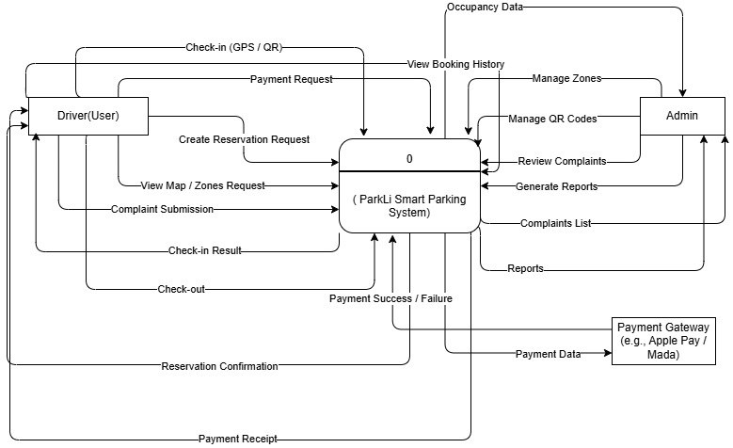
4.2.1 Architecture and Components
Figure 4.1 Data Flow Diagram level o
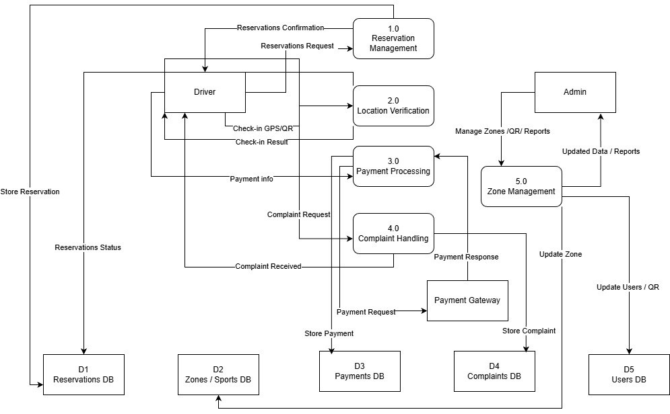
Figure 3.2 Data Flow Diagram level 1

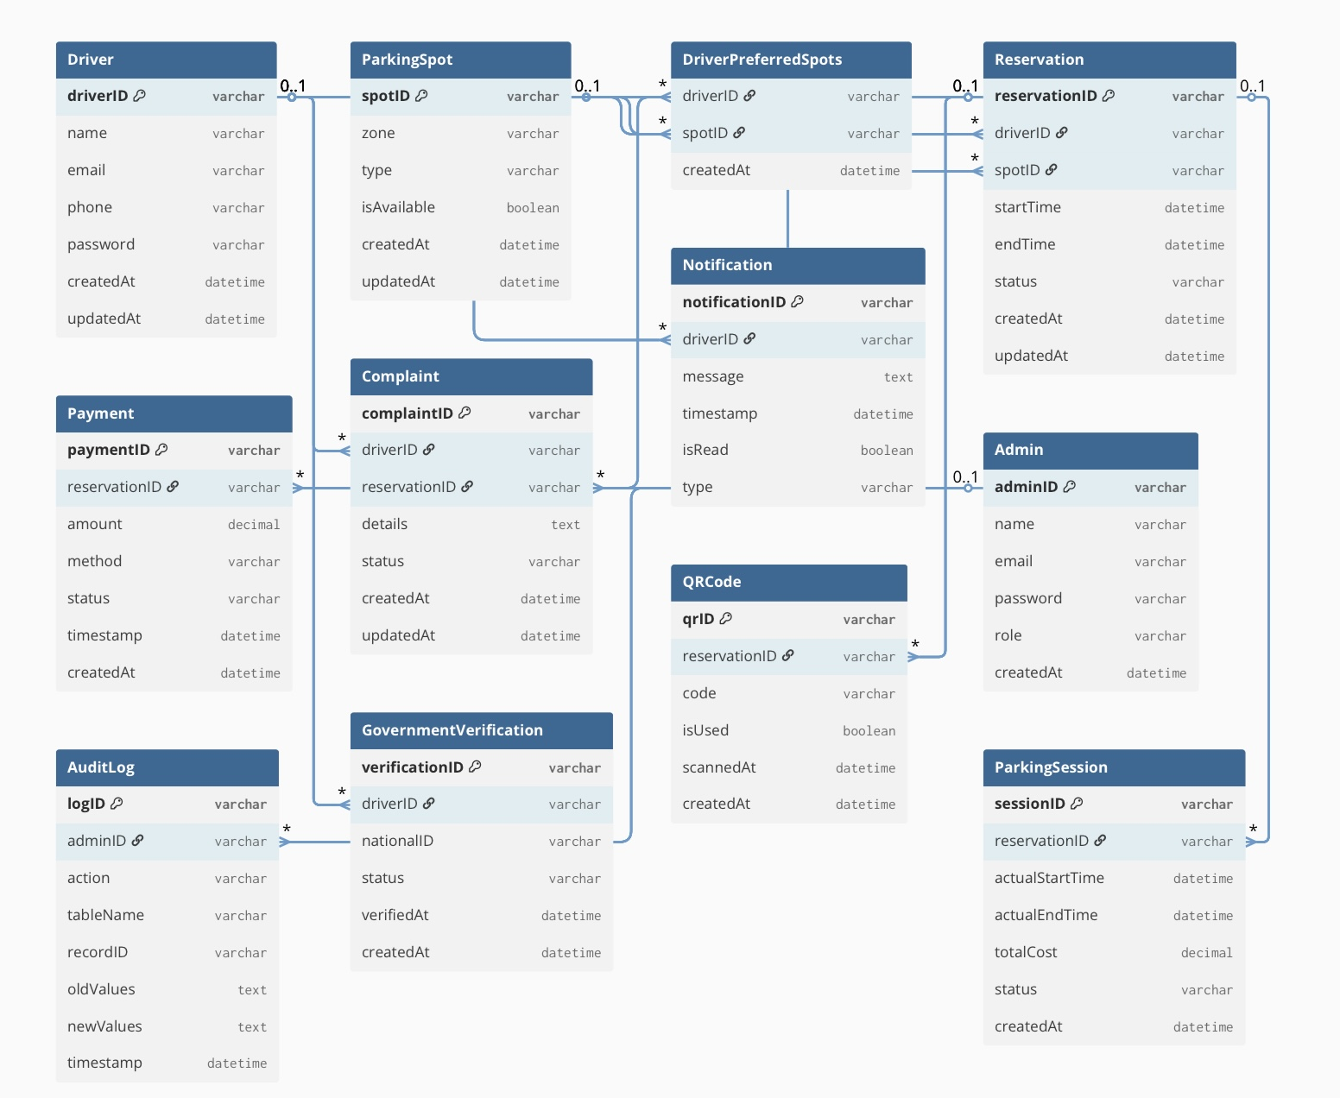
4.2.2 Data Model
Figure 4.3 Data Model

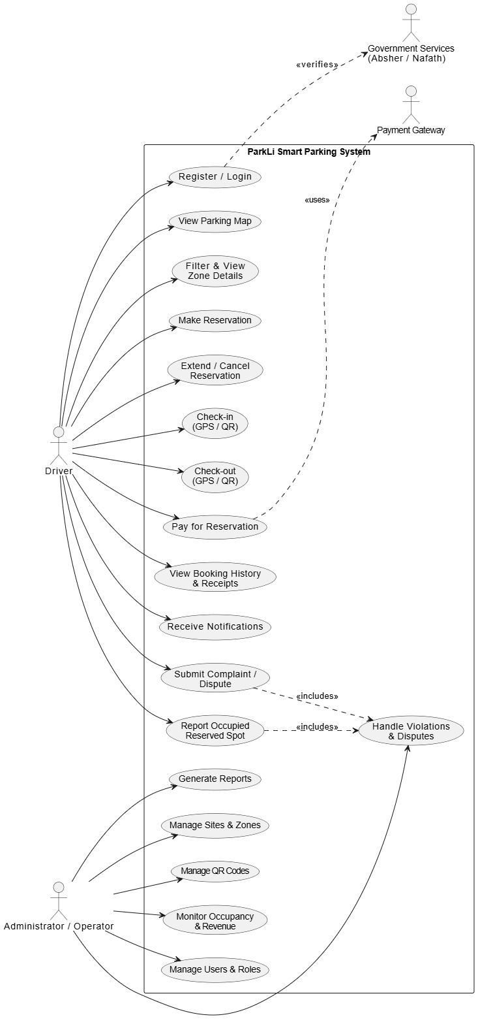
4.3 Design Architecture

4.3.1 UML diagrams

Figure 5.4 Use Case diagram for the ParkLi System.

The diagram illustrating the main interactions between the driver and the ParkLi application, including reservation, check-in, payment, complaints, and history access. The diagram follows standard UML conventions as described in UML Distilled [21].
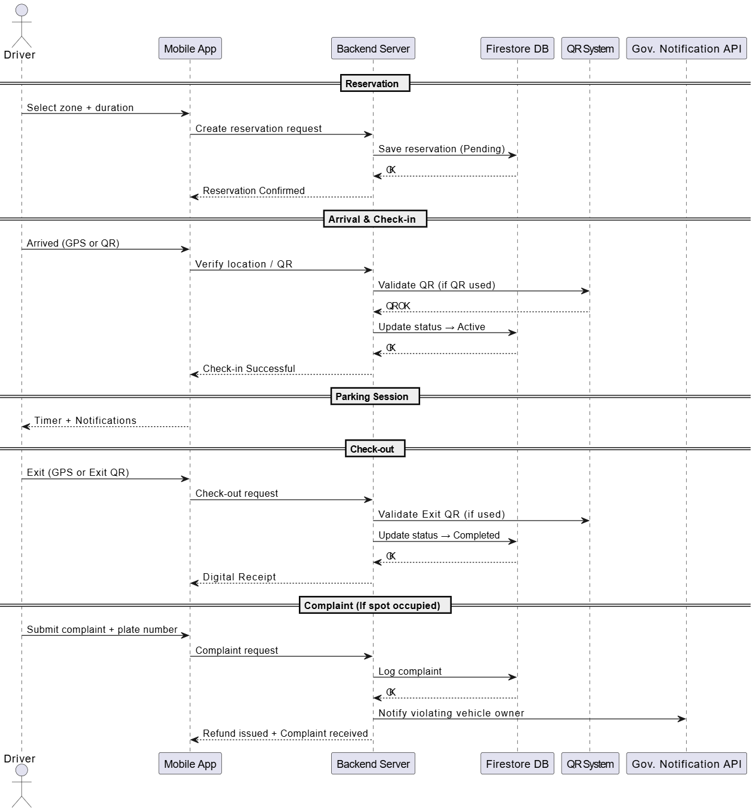

Figure 6.5 Sequence diagram for the ParkLi System.

Figure 4.5 provides the UML Sequence Diagram demonstrating the chronological flow of interactions during the key processes in ParkLi, such as reservation creation, check- in verification (GPS/QR), and payment completion. The diagram follows standard sequence modeling practices described in UML Distilled [21].

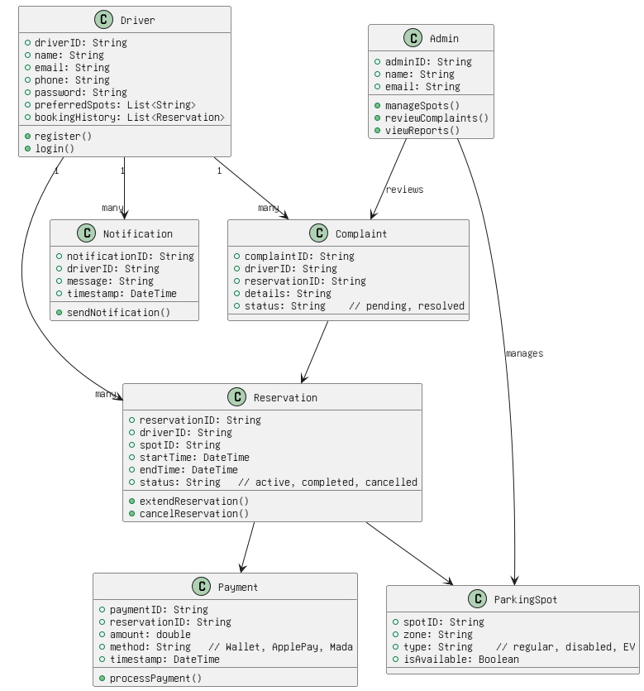

Figure 7.6 Class diagram for the ParkLi System.

The UML Class Diagram of the ParkLi system, illustrating the core system structure, main classes, attributes, methods, and the relationships between them.

4.4 Algorithms / Pseudo-code / Scenario

4.4.1 Scenario
Scenario Title:
End-to-End Operation of the Smart Parking – Smart and Cost-Efficient Version
Description:
This scenario describes the full operation of the Smart Parking System, covering the user experience, backend processes, administrative actions, and the validation mechanisms (GPS, “Arrived” button, and QR scanning). It illustrates how all system components work together to deliver parking reservation, arrival confirmation, monitoring, payment, violation enforcement, and dispute management.
Actors:
• Driver (User)
• Smart Parking Mobile Application
• Backend Server / Database
• QR Codes at Entrance and Exit
• Administrator / Operator
• Notification Service
Pre-conditions:
• The user is registered, authenticated, and has an active device ID.
• Parking zones and policies are configured by the administrator.
• QR codes for entry and exit are active.
• GPS is enabled on the user’s device.

- User Registration and Login
1.1 Registration
1.1.1 The user installs the Smart Parking application. 1.1.2 The user registers using email or phone number. 1.1.3 The backend verifies the user and links the device ID.
1.2 Login
1.2.1 The user logs into the app. 1.2.2 The user is redirected to the home screen and map view.
- Viewing Parking Zones
2.1 Loading Zones
2.1.1 The app requests the user’s current GPS location. 2.1.2 The backend returns active parking sites and available spots.
2.2 Browsing Zones
2.2.1 The user views available zones on the interactive map. 2.2.2 The user applies filters (distance, availability, price, category).
- Making a Reservation
3.1 Selecting Zone
3.1.1 The user selects a parking zone.
3.1.2 The user chooses a reservation time or duration.
3.2 Confirming Reservation
3.2.1 The backend validates availability and pricing rules. 3.2.2 A reservation is created with the status “booked.” 3.2.3 A push notification confirms the reservation.
- Approaching the Parking Area
4.1 Entering the Geofence
4.1.1 When the user enters the 75m geofence radius, the app detects arrival. 4.1.2 A prompt asks the user to confirm arrival.
4.2 Grace Period
4.2.1 A 5-minute arrival grace period begins. 4.2.2 A reminder notification is sent if needed.
- Check-In Process
5.1 GPS / Button-Based Check-In
5.1.1 The user taps the “Arrived” button. 5.1.2 The backend validates GPS coordinates. 5.1.3 The reservation becomes “active.”
5.2 QR-Based Check-In
5.2.1 If GPS is weak, the user scans the entrance QR code. 5.2.2 The system logs QR_ENTER. 5.2.3 The reservation becomes “active.”
- During Parking Session
6.1 Monitoring
6.1.1 The system tracks the parking duration. 6.1.2 Occupancy data is updated in real time.
6.2 Notifications
6.2.1 User receives a “Session Started” notification. 6.2.2 User receives time remaining alerts. 6.2.3 Overstay warnings are sent if applicable.
- Check-Out Process
7.1 Automatic GPS Check-Out
7.1.1 When the user exits the geofence radius, the app detects departure. 7.1.2 The reservation is marked “completed.”
7.2 QR Check-Out
7.2.1 If GPS is unavailable, the user scans the exit QR. 7.2.2 The system logs QR_EXIT and completes the session.
- Payment and Receipt
8.1 Calculating Payment
8.1.1 The system calculates the fee based on actual usage for hourly zones. 8.1.2 Pricing rules are applied according to policy.
8.2 Completing Payment
8.2.1 The user pays via wallet / basic payment method. 8.2.2 A digital receipt is generated and stored in booking history.
- Violation Handling
9.1 No-Show Violation
9.1.1 The user fails to confirm arrival within the grace period. 9.1.2 Reservation changes to “no_show.” 9.1.3 A violation with fee/points is created. 9.1.4 The user is notified.
9.2 Overstay Violation
9.2.1 The user exceeds the reserved time. 9.2.2 Overstay duration is calculated. 9.2.3 A violation is issued automatically.
- Dispute Submission
10.1 User Submission
10.1.1 The user opens the violation details. 10.1.2 The user submits a dispute with photos/notes. 10.1.3 The system stores the dispute as “pending review.”
10.2 Admin Notification
10.2.1 Admin receives a dispute alert.
- Admin Dashboard Operations
11.1 System Management
11.1.1 Admin logs into the dashboard. 11.1.2 Admin manages sites, zones, capacity, and operation hours. 11.1.3 Admin adjusts policies and pricing categories. 11.1.4 Admin manages QR tokens for entry/exit.
11.2 Monitoring
11.2.1 Admin views occupancy and real-time activity. 11.2.2 Admin reviews violations and disputes. 11.2.3 Admin exports reports (CSV/Excel).
- Administrative Review
12.1 Decision Making
12.1.1 Admin reviews disputes with timestamped events. 12.1.2 Admin approves or rejects the dispute.
12.2 Updating the System
12.2.1 Violation status is updated accordingly. 12.2.2 User receives the dispute decision notification.
Post-conditions:
• Reservation is completed, cancelled, or recorded as no-show.
• All events (GPS entry, QR scan, arrival, exit) are logged.
• Payments, violations, and disputes are stored for 90 days.
• System dashboards reflect updated occupancy and revenue.
Success Criteria:
• User can reserve, arrive, and exit using at least one validation method.
• System accurately logs all actions and enforces policies.
• Admin receives correct, traceable data for monitoring and decision-making.

4.5 User Interface (UI) design
This section is dedicated to the design of a user-friendly interface of the ParkLi application, its clarity, simplicity, and ease of interaction. As a user should find a place to park, see the availability, book a spot, and make payments, the UI is intended to reduce the efforts and help users make a fast decision. The design focuses on simple navigation, visual clarity, and regular structure of all the screens. The overall design was based on user needs, system requirements and accessibility principles. The interface is also meant to ease confusion by ensuring that information is displayed in a clean and organized format. Besides, the real-time map interactions and QR-scanning services are designed to be user-friendly and easy to use.

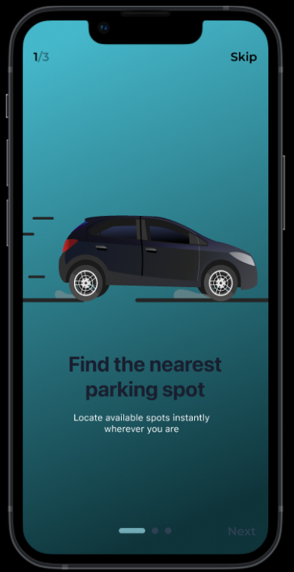
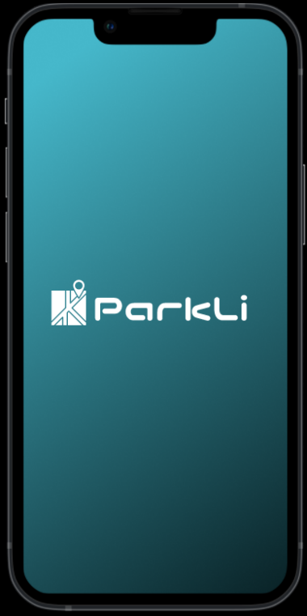
Figure 8.8 Onboarding Screen
Figure 9.7 Splash Screen
The Splash Screen, as shown in Figure 4.7, is the initial screen that presents the user with an introduction to the application in a clean, simple layout. The next screen is the Onboarding Screen, which is shown in Figure 4.8, and it provides a short explanation of the main goal of the app, which is to find parking spots conveniently. All these screens guarantee a well-fluent user experience.

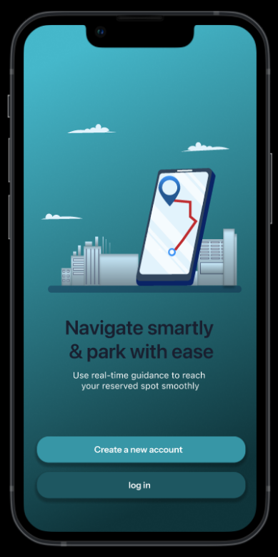
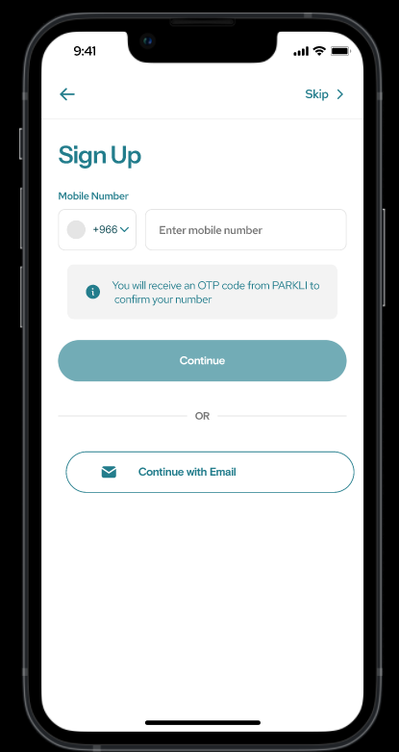
Figure 10.10 Sign-up Screen
Figure 11.9 Login and Registration Screen
The Login and Registration screen, as shown in Figure 4.9, offers two distinct options to users: the creation of a new account and logging in to an existing account. This design assists users in making decisions on their way of proceeding and using the app. The Sign-up page, shown in Figure 4.10, enables a user to create an account by providing their mobile number to get a verification code in the form of an OTP. The user can also create a new account using email. It has a clear and easy layout which makes users find the registration process easily.

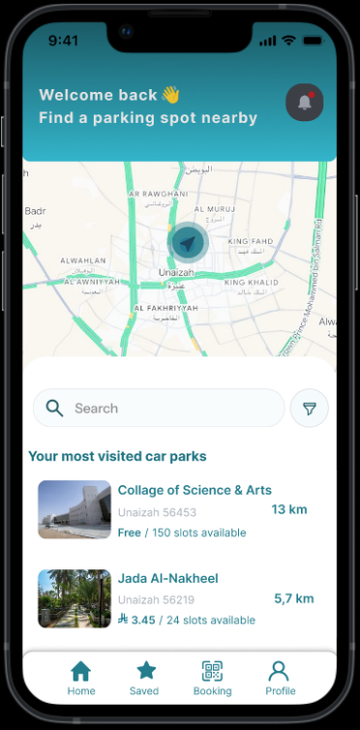

Figure 12.11 Home Screen

The Home screen, shown in Figure 4.11, represents the current position of the user on the map and allows users to locate the available parking spaces nearby. It also offers a search bar, a filter selection, and a list of the car parks that the user visited the most along with the distance and availability.
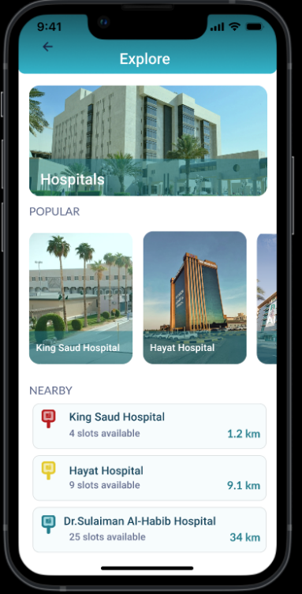
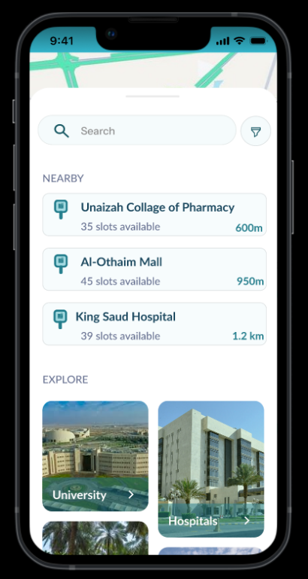
Figure 13.13 Explore Screen
Figure 14.12 Search Screen

The Search screen, shown in Figure 4.12, enables the user to find parking spots and see nearby places depending on their present location. It also has an Explore section where the user can browse available parking by category, like universities, hospitals, and malls. The Explore screen, shown in Figure 4.13, represents the page that can be viewed when a user clicks on a certain category. It shows the popular places in that category as well as the nearby ones with their current parking status (available, limited, or busy).

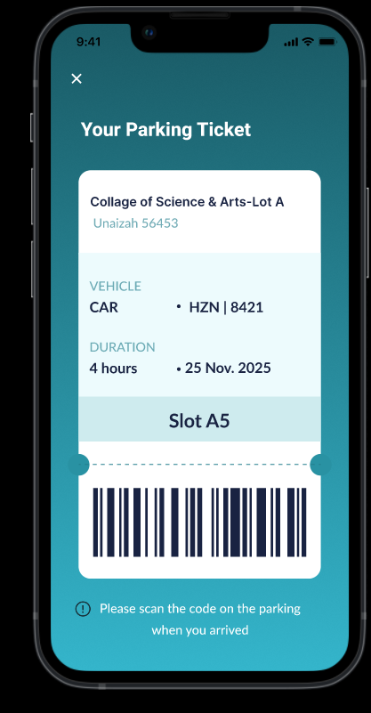
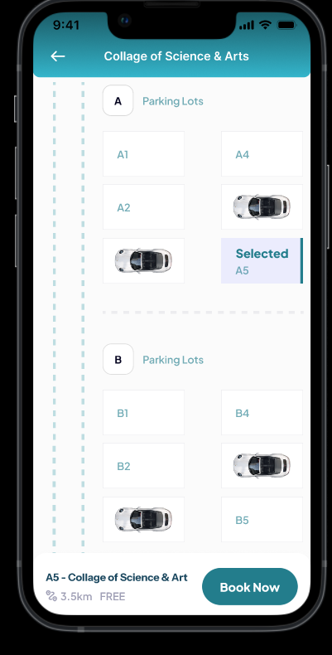
Figure 15.15 Parking Ticket Screen
Figure 16.14 Parking Selection Screen

The Parking Selection Screen, shown in Figure 4.14, enables the user to explore all the parking lots provided and see real-time availability. All the slots are displayed with clear display, and the user can choose any spot available. Once a parking space is selected, the user will have an opportunity to book a parking space by choosing the date, time, and other necessary information. The Parking Ticket Screen, as shown in Figure 4.15, is displayed once the user has gone through the booking process. It shows the parking area, parking slot, vehicle details, time, and a barcode which can be scanned. With the arrival, the ticket is used to confirm the reservation.

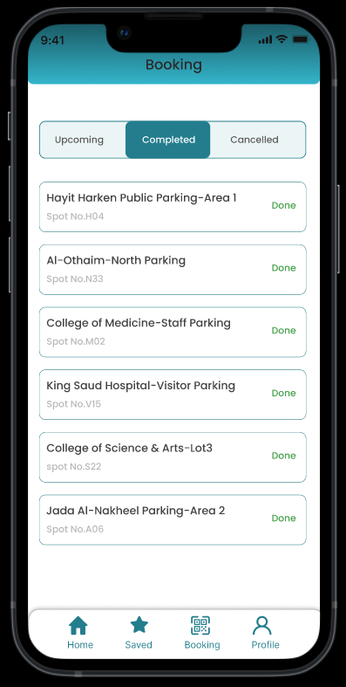
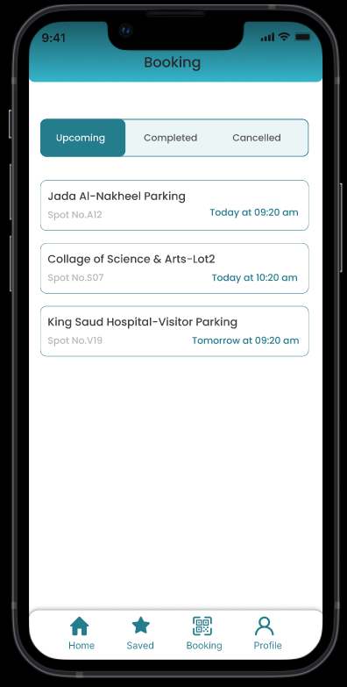
Figure 17.17 Completed bookingg Screen
Figure 18.16 Upcoming booking Screen
The upcoming booking screen, which is shown in Figure 4.16, contains all upcoming reservations. The user can revise, update or cancel any future booking. This assists the users to effectively manage their booked parking. The Completed Bookings Screen, shown in Figure 4.17, presents all the past reservations with their details. It gives users the ability to track their parking history.
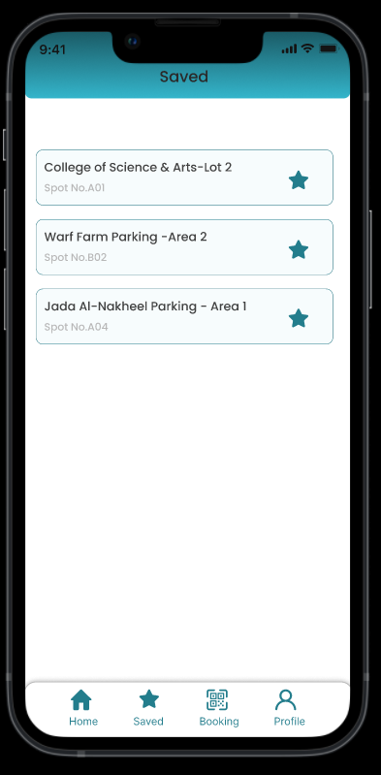
Figure 19.18 Saved Parking Screen

The Saved Parking Screen, as shown in Figure 4.18, allows the user to save their favorite or common parking places. This helps users to easily access and reserve the spots they frequent most.

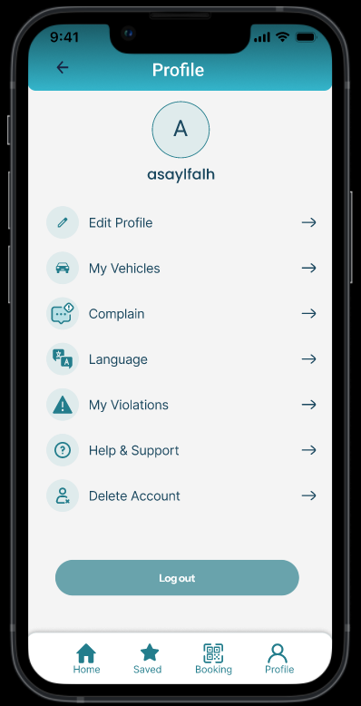
Figure 20.19 User Profile Screen
The User Profile Screen, which is shown in Figure 4.19, offers the user the chance to find everything that is related to their account on a convenient page. Through this screen, the user can easily update personal details, handle registered vehicles, make complaints, change the language, see violations, get help and support, or delete the account as desired. The design is created in such a way that every choice is visible and reachable so that a user can navigate their profile settings effectively.

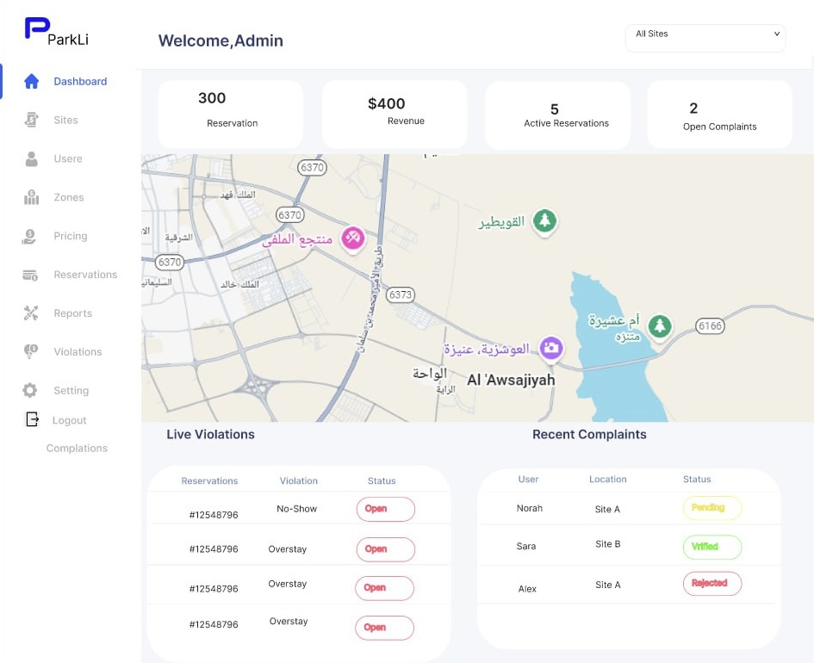
4.6 Admin dashboard design
Figure 21.20 Admin Dashboard

The Admin Dashboard screen, shown in Figure 4.20, provides the administrator with a comprehensive overview of all system-related data and management tools on a single, convenient page. Through this screen, the admin can easily monitor key metrics such as active reservations, revenue, open complaints, and live violations. It also allows for efficient management of users, zones, pricing, reservations, reports, and system settings. The interface is designed to be clear and accessible, ensuring the administrator can navigate and oversee daily operations effectively and make informed decisions promptly.

4.7 Summary
The chapter 4 of the Smart Parking System project presented the overall system design. It introduced the general design and determined the main elements of the design with a concrete data model, including entities like Driver, Reservation, Payment, and Parking Session. The chapter was also affirmative on the critical algorithms and step-by-step operational situations of the whole parking process, including reservation and GPS/QR-based check-in, check-out, and payment. Moreover, it has implemented the user-friendly interface design of the ParkLi application and administrative dashboard. It is a very important blueprint that represents the requirements of the system into a designed and feasible plan and provides a clear roadmap to the next stage of the implementation of the Smart Parking System.

References
[1] Ghazal, B., et al. (2016). Smart traffic light control system. IEEE Xplore. https://ieeexplore.ieee.org/abstract/document/7470780/
[2] Anagnostopoulos, C. N., et al. (2008). License plate recognition from still images and video sequences. IEEE Transactions. https://ieeexplore.ieee.org/abstract/document/4518951/
[3] Flutter. Flutter documentation, 2025. URL https://docs.flutter.dev/
[4] Microsoft. Visual studio code, 2025. URL https://code.visualstudio.com/
[5] Google. Android studio, 2025. URL https://developer.android.com/studio
[6] Google. Firebase, 2025. URL https://firebase.google.com/
[7] Git. Git- distributed version control system, 2025. URL https://git-scm.com/
[8] Inc. Figma. The collaborative interface design tool, 2025. URL https://www.figma.com/
[9] Inc. Notion Labs. Notion, 2025. URL https://www.notion.so/
[10] Overleaf- Online LaTeX Editor, 2025. URL https://www.overleaf.com/
[11] Lin, X., et al. (2017). Smart parking impact on urban mobility. IEEE Xplore. https://ieeexplore.ieee.org/abstract/document/10758649
[12] Montanez, J., et al. (2020). IoT-based parking systems. uniminuto.edu. https://repository.uniminuto.edu/server/api/core/bitstreams/d0a67e43-931b-49ae-85cb-1022d496a780/content
[13] Amato, F., et al. (2019). Cloud-enabled parking analytics. ResearchGate. https://www.researchgate.net/profile/120132-120146-120159-120171-120160-120160-120163-95-120120-120159-120164-120146-120163-120154/publication/366963183_Internet_of_things_IoT_fusion_with_cloud_computing_current_research_and_future_direction/links/63c18008d9fb5967c2d335b9/Internet-of-things-IoT-fusion-with-cloud-computing-current-research-and-future-direction.pdf
[14] Khanna, A., & Anand, R. (2021). Camera-based parking systems and privacy. ResearchGate. https://www.researchgate.net/profile/Seyed-J-Faraji/publication/357975010_Infrastructure_and_strategies_for_designing_camera-centric_smart_parking_in_developing_countries_case_study_Iran_Scopus_Italy/links/61ebb0ef8d338833e38759eb/Infrastructure-and-strategies-for-designing-camera-centric-smart-parking-in-developing-countries-case-study-Iran-Scopus-Italy.pdf
[15] Rebello, J., & Kumar, P. (2022). IoT sensor parking reliability. IEEE Xplore. https://ieeexplore.ieee.org/abstract/document/10151507
[16] Yusoff, S., et al. (2021). Evaluation of sensor parking technologies. IEEE Xplore. https://ieeexplore.ieee.org/abstract/document/10292845
[17] Lee, H., & Park, J. (2023). GPS-only parking verification limitations. IEEE Xplore. https://ieeexplore.ieee.org/abstract/document/10198231
[18] Khanna, A., & Anand, R. (2021). QR-based parking validation systems. IEEE Xplore. https://ieeexplore.ieee.org/abstract/document/10714586/
[19] Dyba, T., & Dingsoyr, T. (2008). Empirical studies of Agile software development: A systematic review. ScienceDirect. https://www.sciencedirect.com/science/article/pii/S0950584908000256
[20] The Standish Group. (2020). CHAOS 2020: Beyond Infinity. Official industry report; access requires subscription (no public link available).
[21] M. Fowler. (2018). UML Distilled: A Brief Guide to the Standard Object Modeling Language. Addison-Wesley Object Technology Series. Pearson Education. https://books.google.com.sa/books?id=VTdtDwAAQBAJ

